

***INSTITUTE OF INFORMATION TECHNOLOGY***

***JAHANGIRNAGAR UNIVERSITY***

**Number of Assignment :** 04

**Submission Date :** 04/08/2022

**Course Tittle :** Theory of Computing

**Course Code :** ICT - 3105

**Submitted To Submitted By**

Dr. Rashed Mazumder Md. Shakil Hossain

Assistant Professor Roll – 2023

IIT – JU 3nd year 1st Semester

IIT – JU

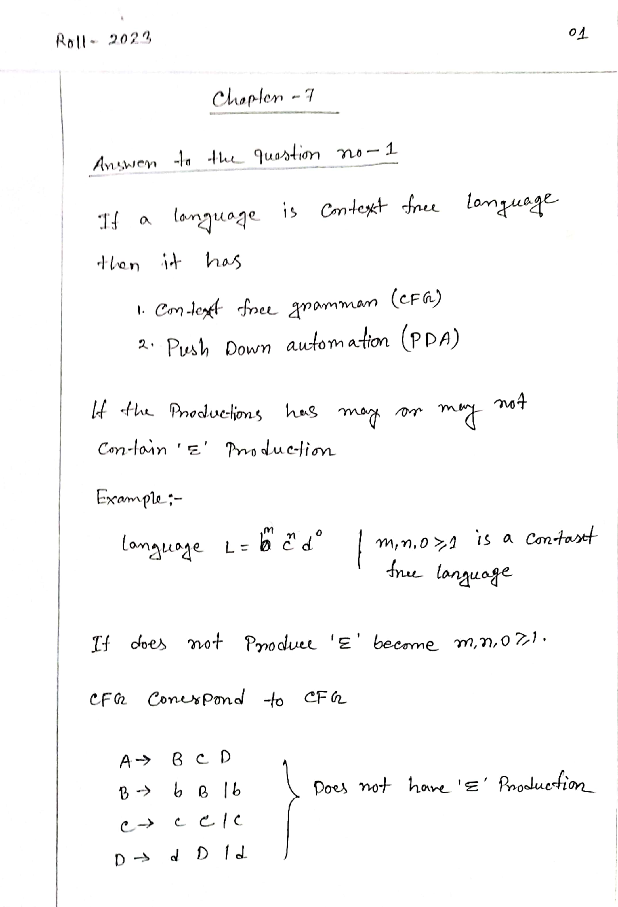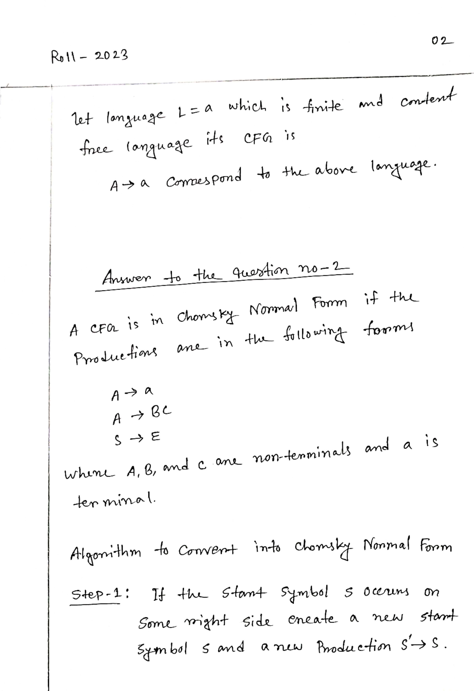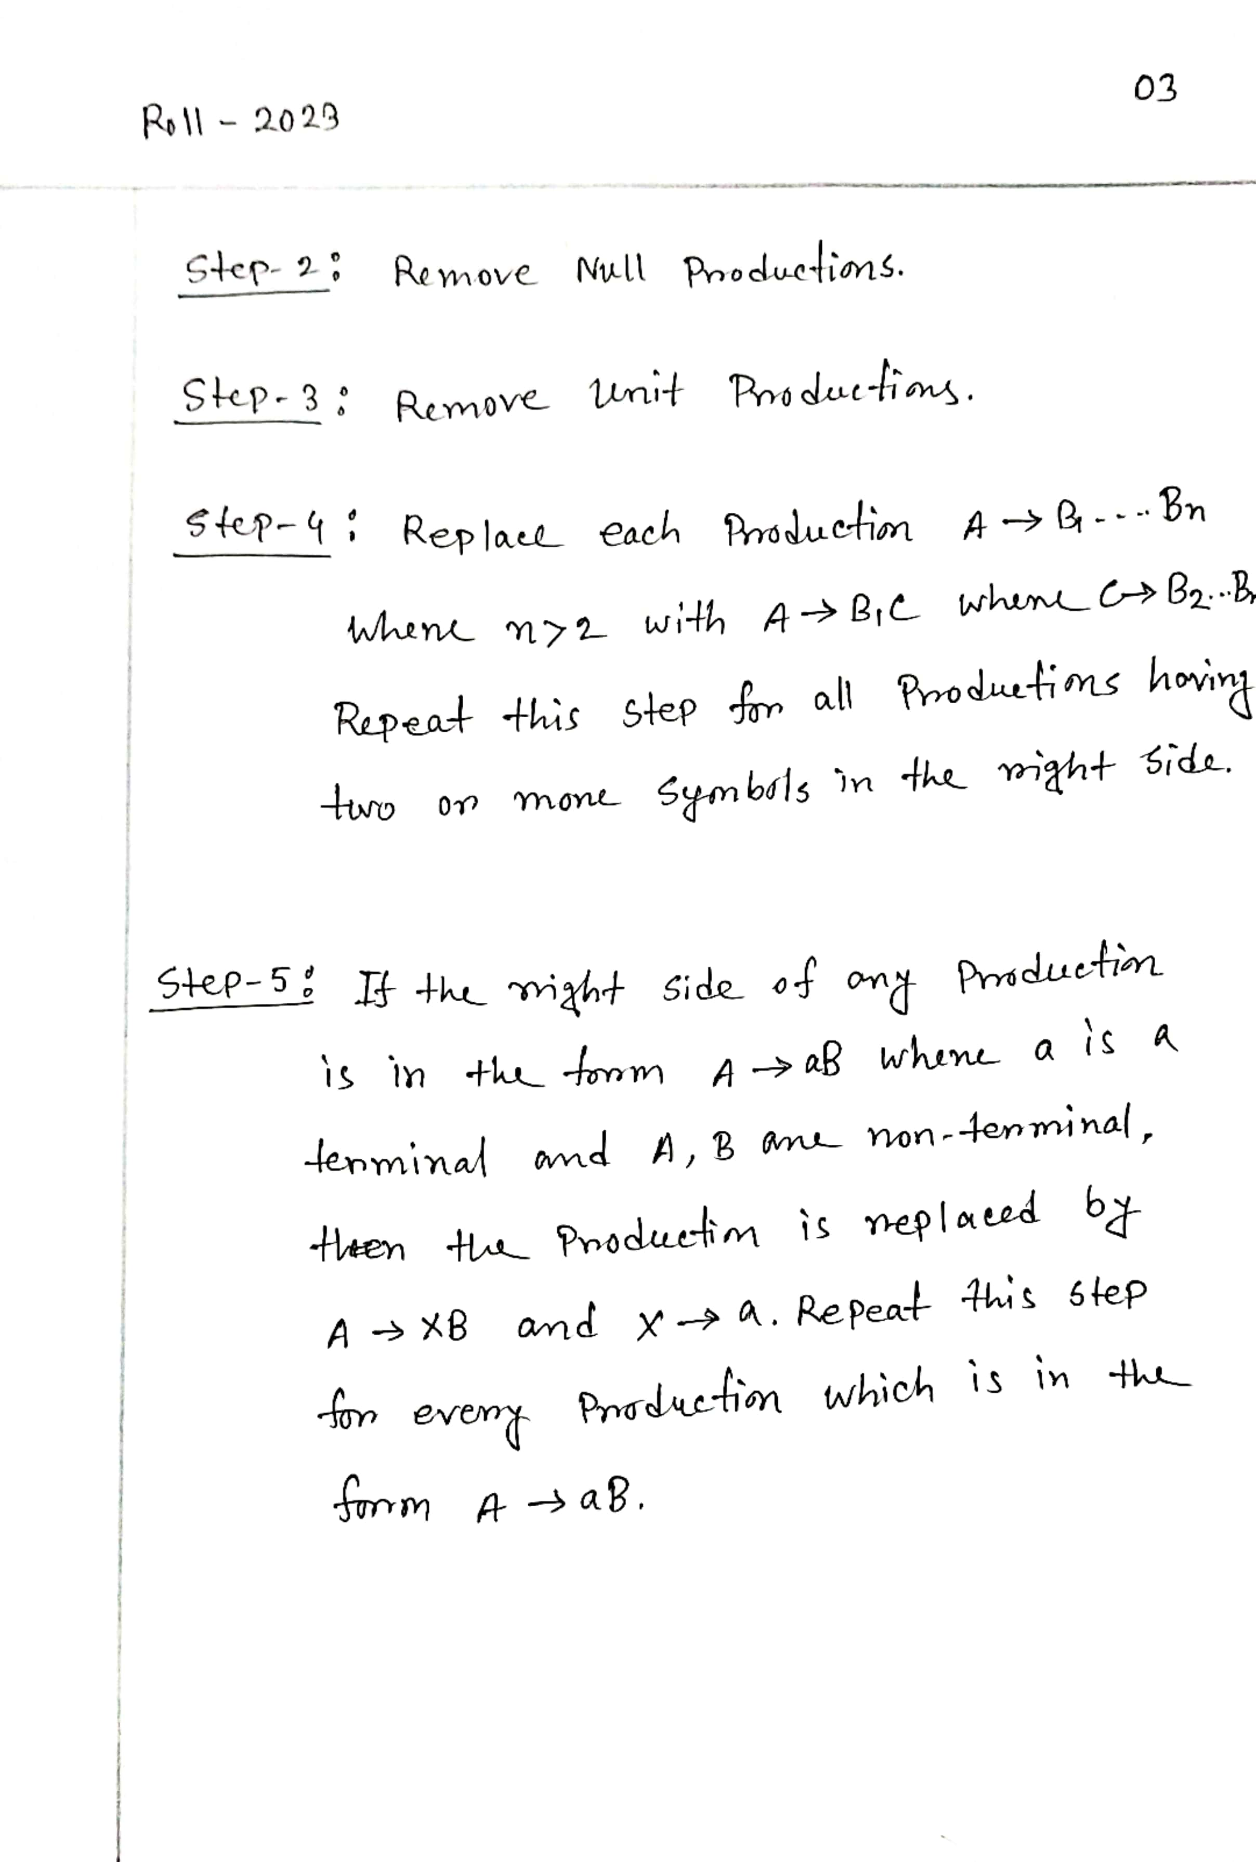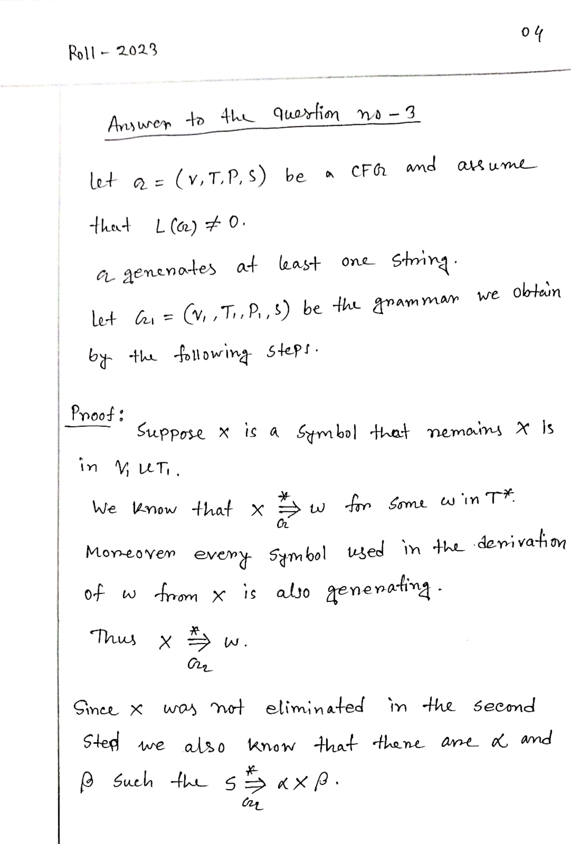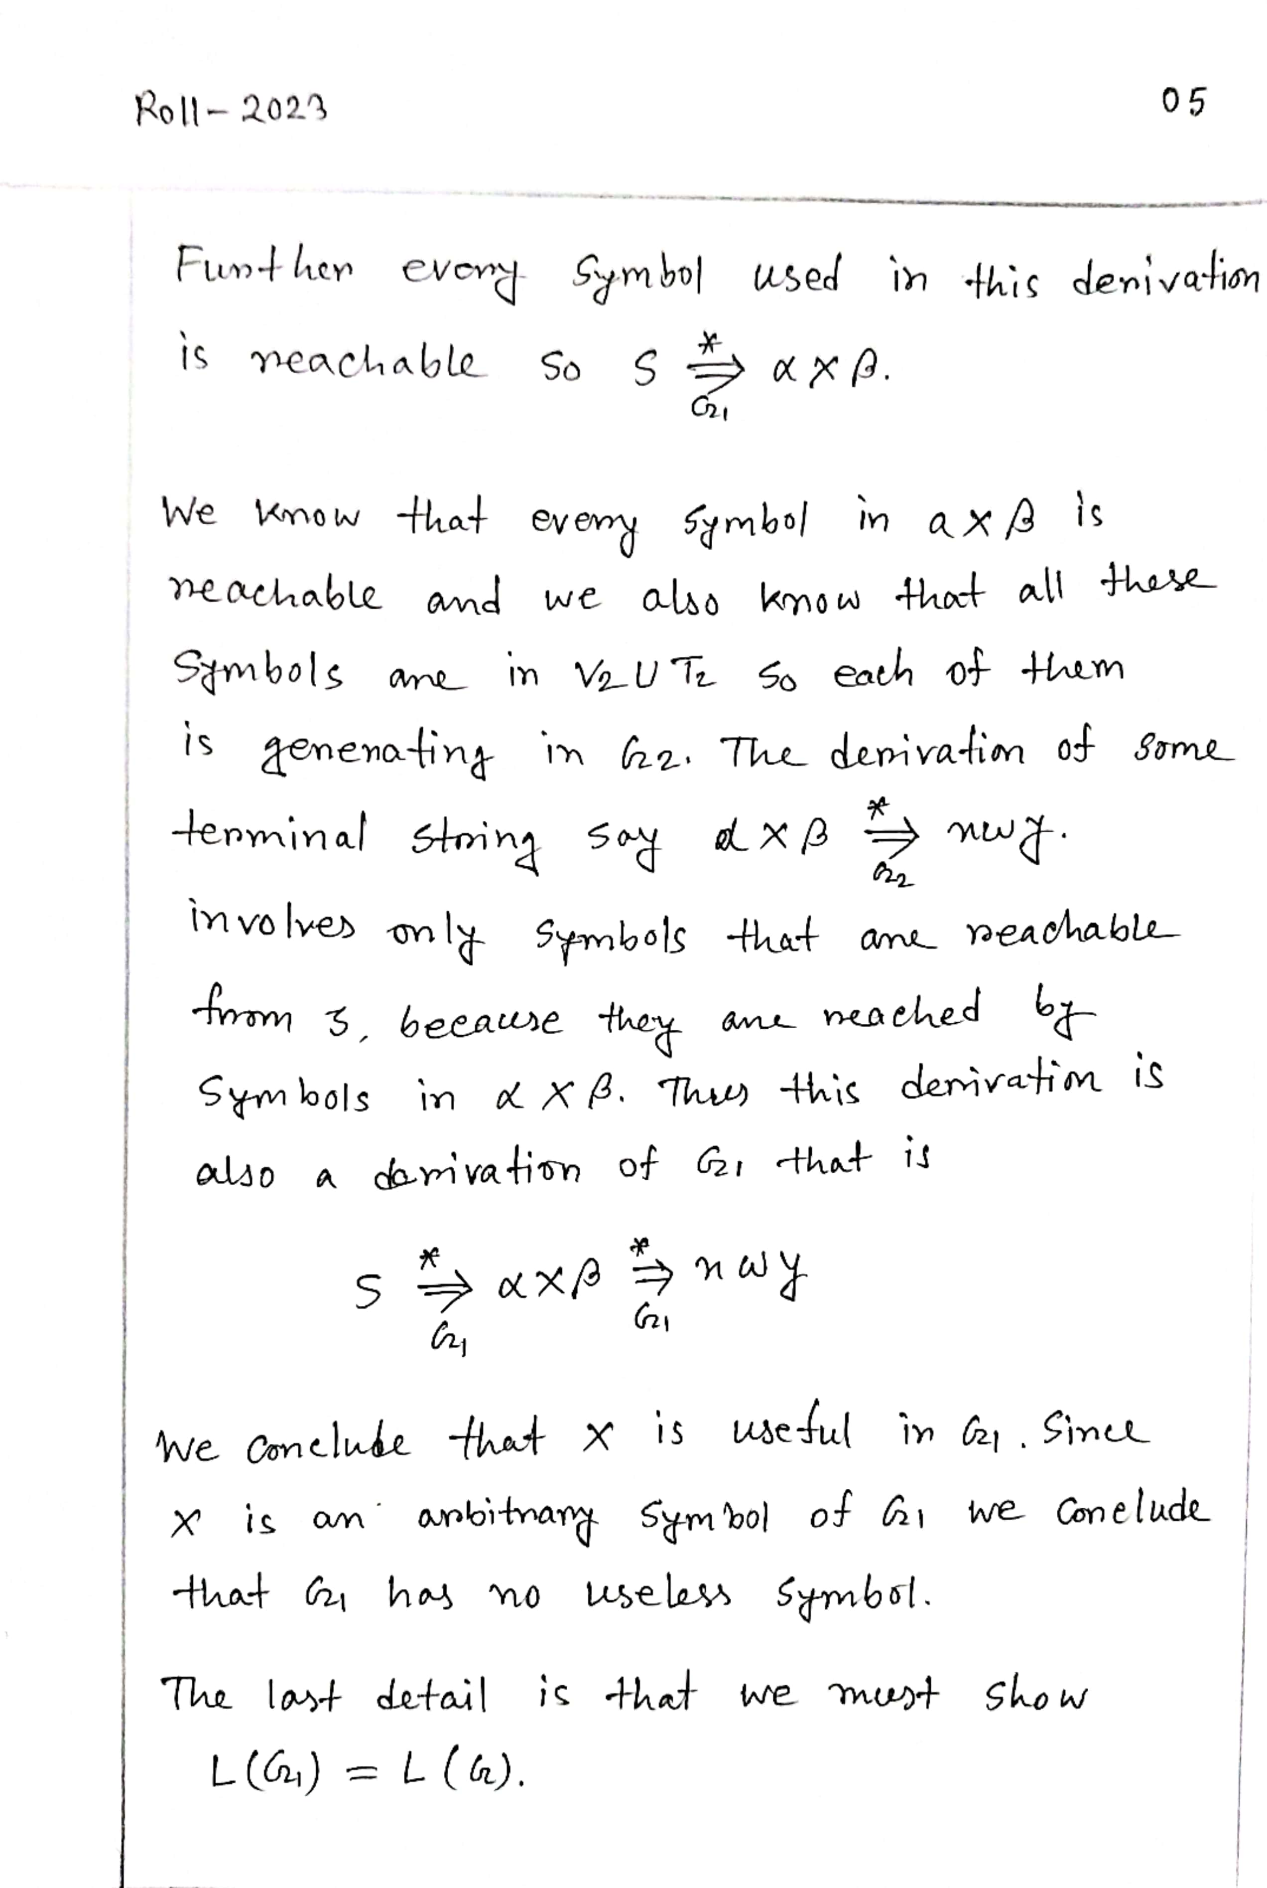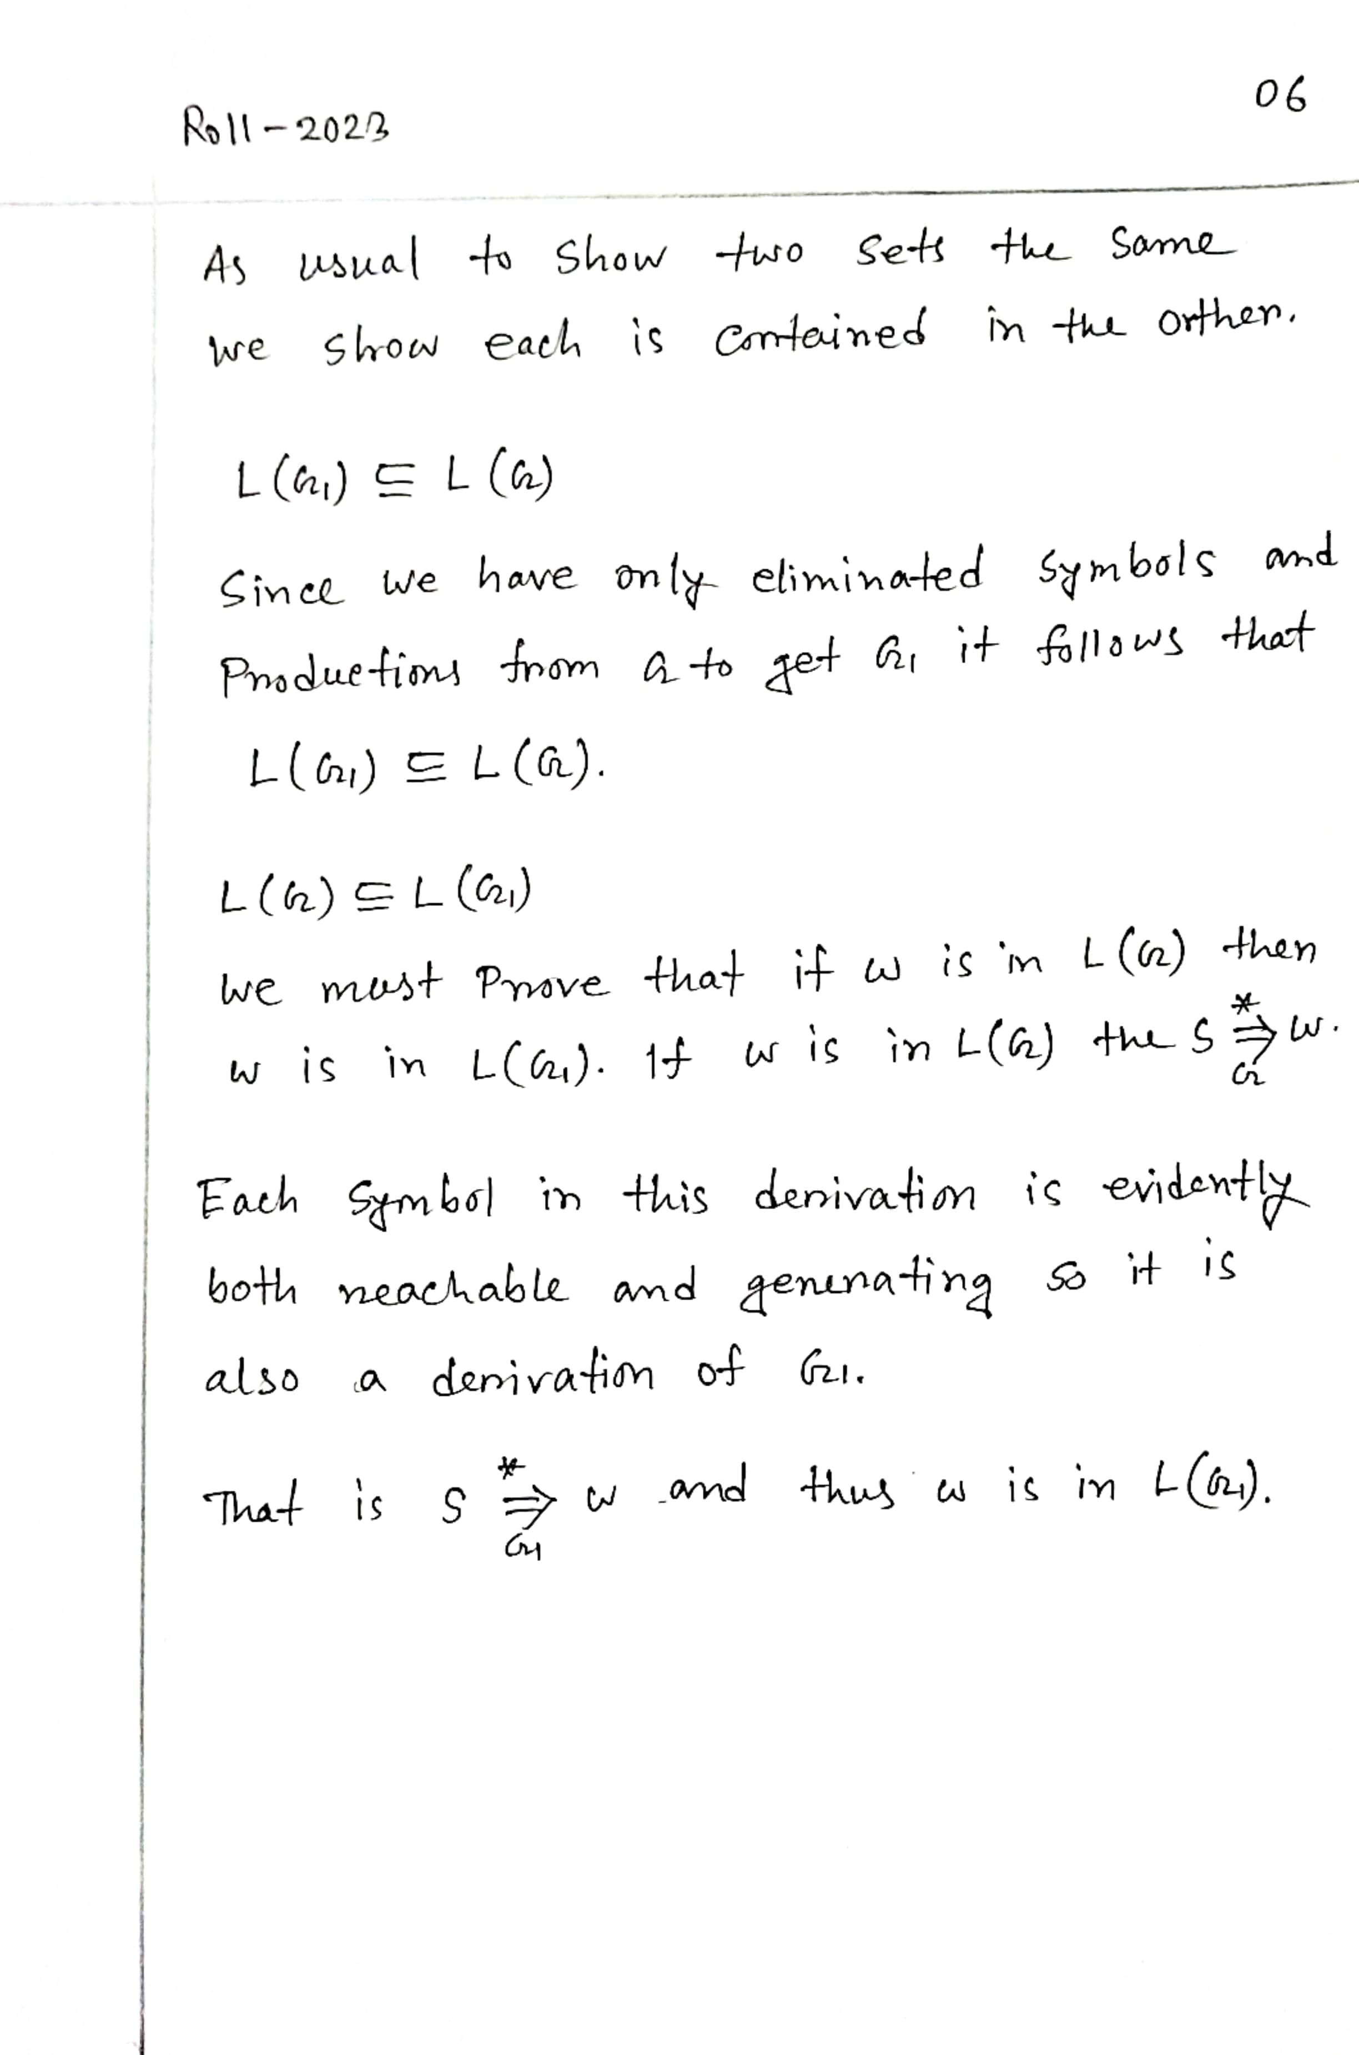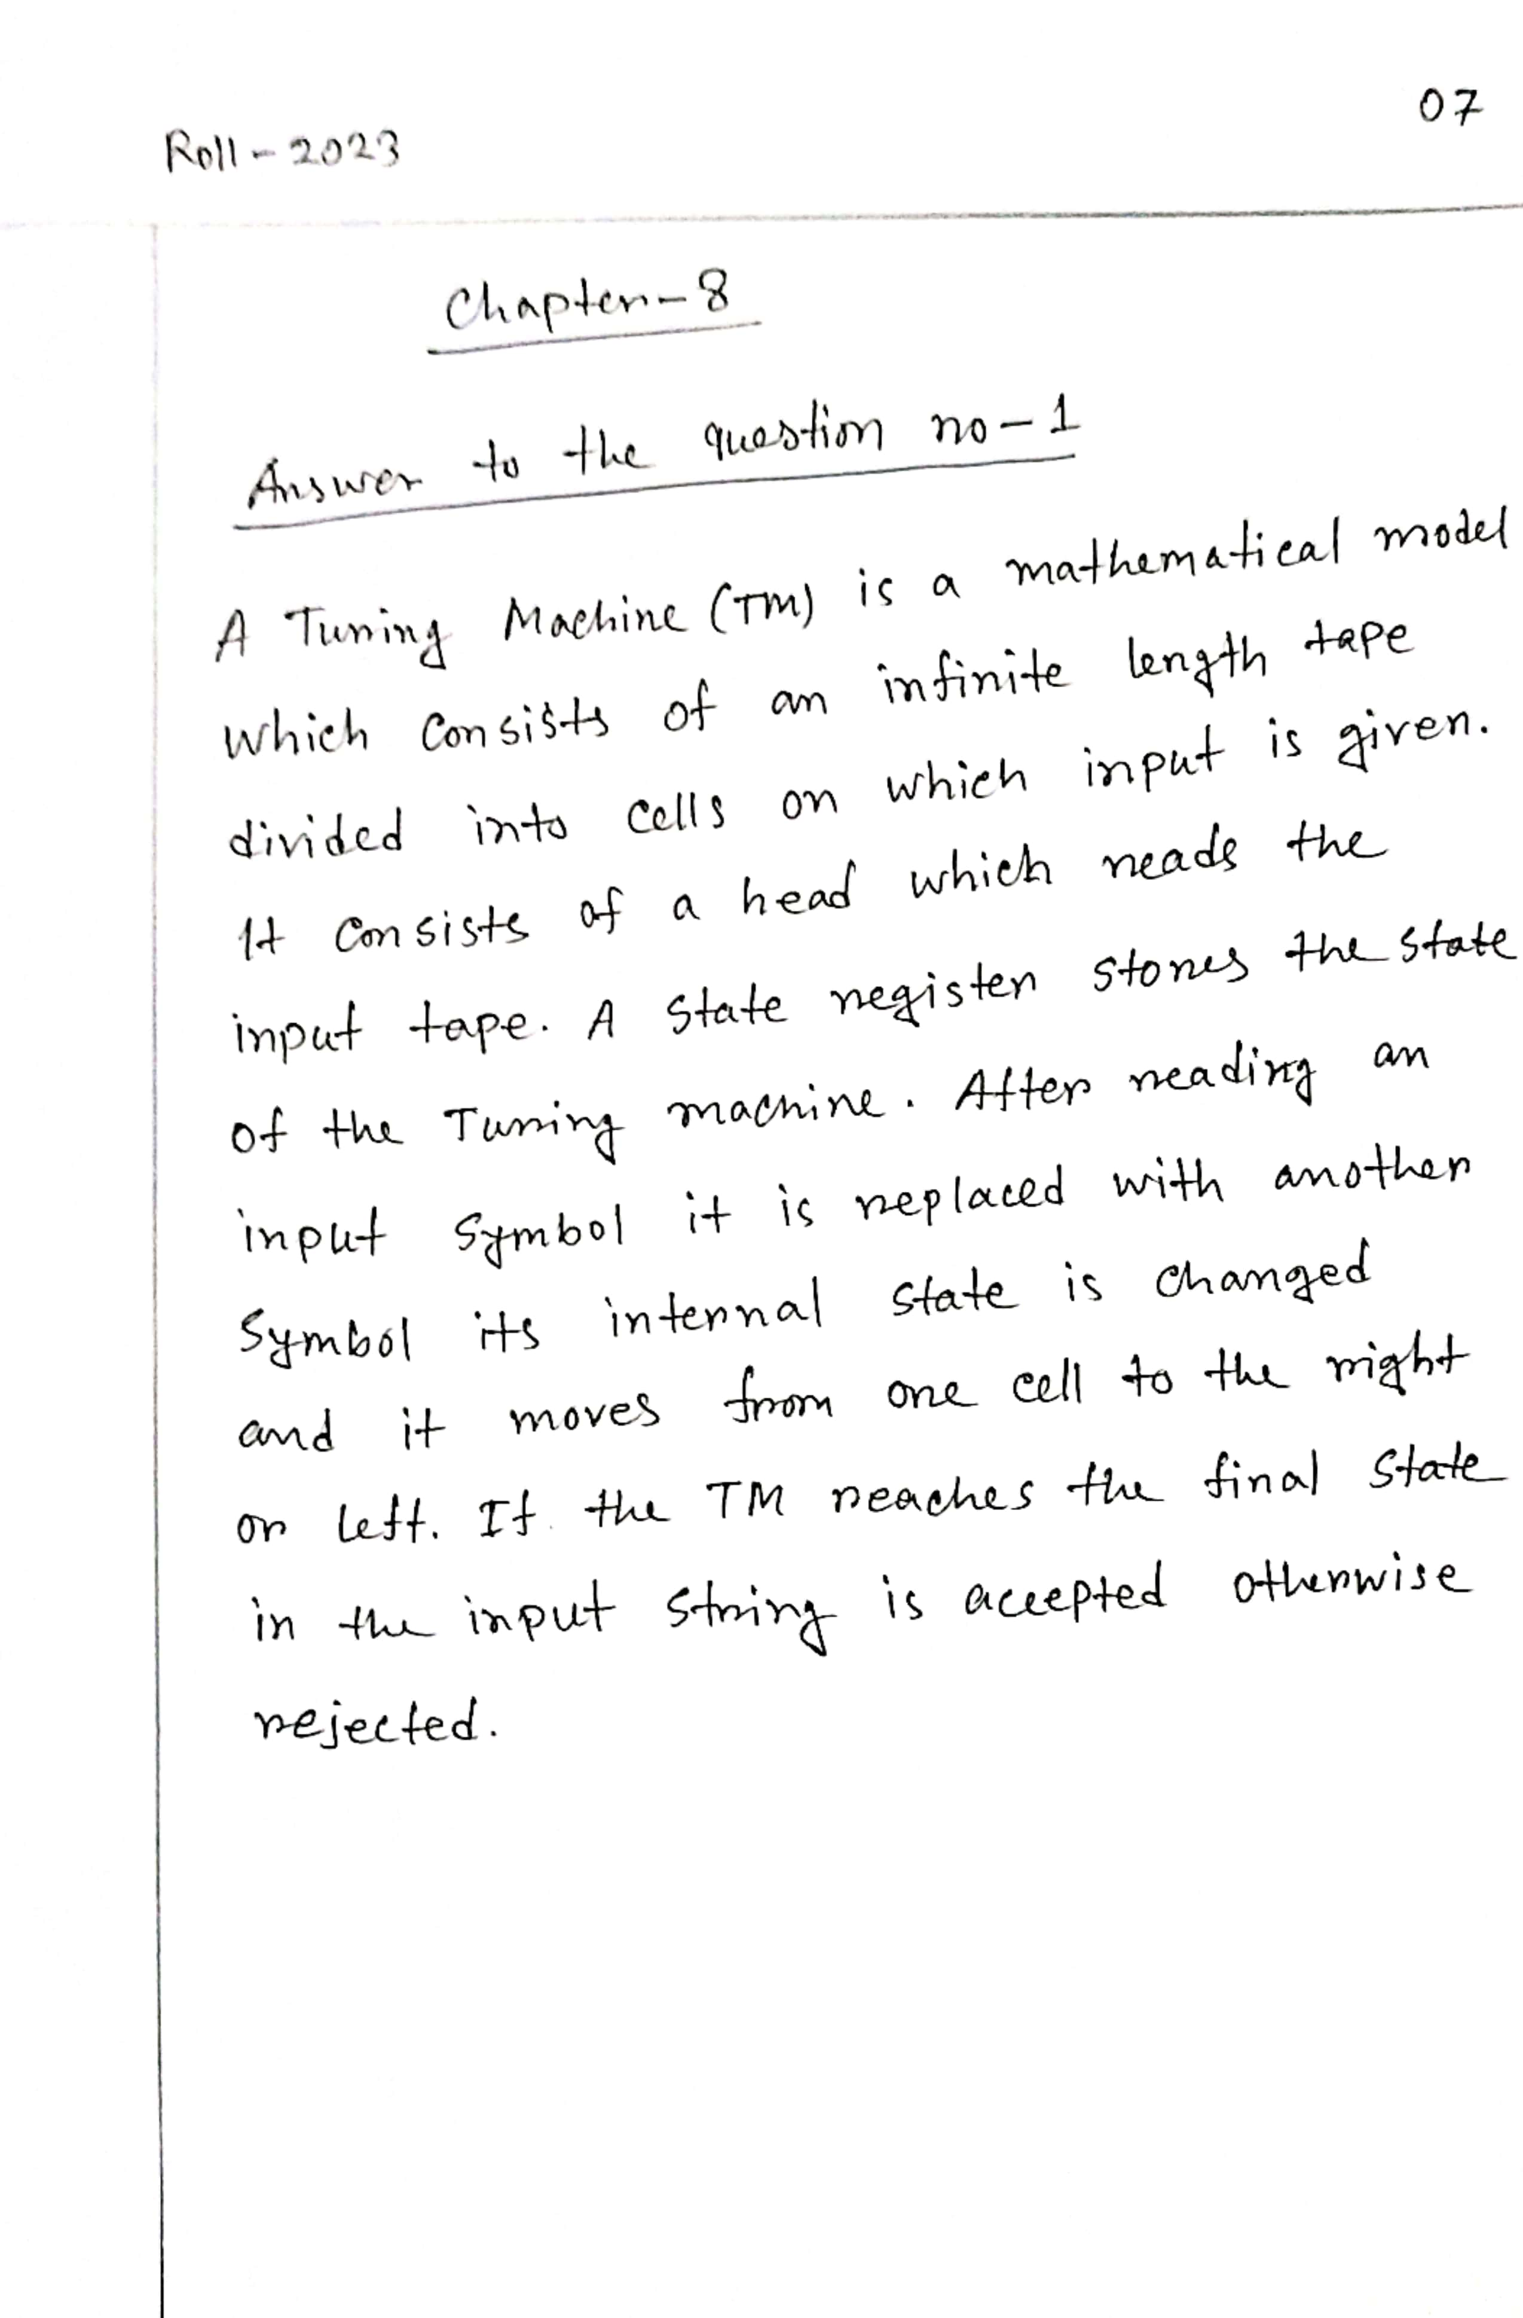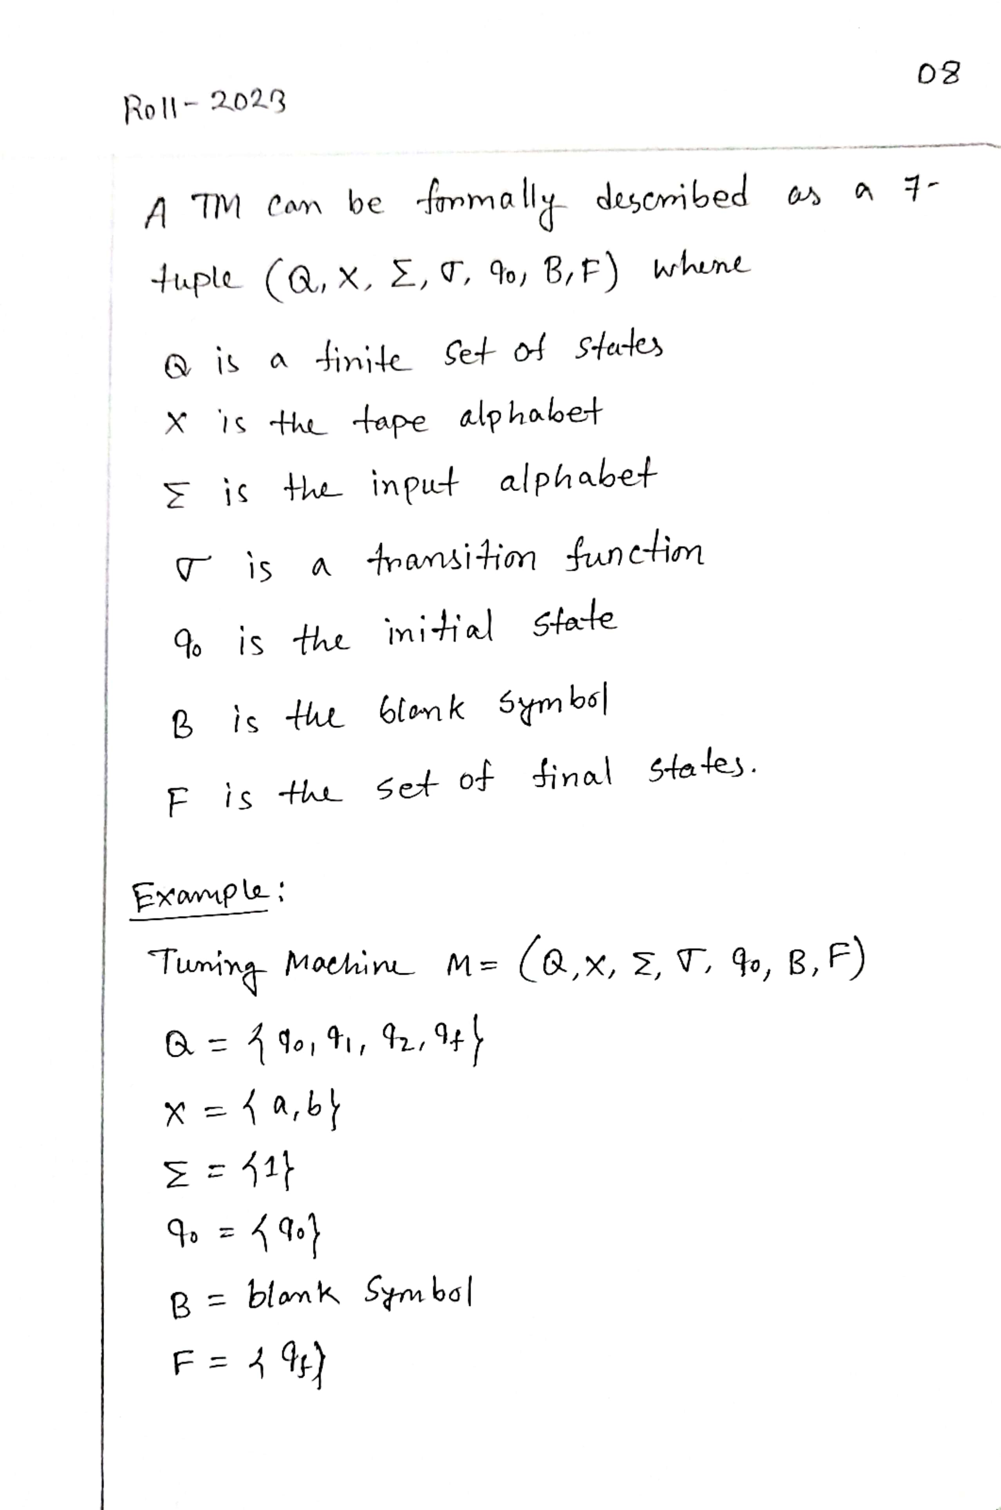

**THE END**